Lockout/Tagout (LOTO) Procedure

Office of Administrative Responsibility | Agri-Food Discovery Place
Approver | Executive Director
Scope | Compliance with this procedure extends to all employees, faculty, students, researchers, clients, contractors, sub-contractors, visitors and suppliers at Agri-Food Discovery Place

Overview
Health and Safety is an integral part of all our business and research activities at Agri-Food Discovery Place, and we are continually working towards making measureable improvements in the health and safety aspects of our workplace on an ongoing basis.

Purpose
This procedure establishes minimum requirements to prevent unexpected energizing startup, or release of stored energy that may result in injury to personnel during maintenance or cleaning of machinery, equipment, or powered mobile equipment. See hazardous energy in Definition section.

If the task involves the use of flame, sparks or any other hot work (see Hot Work in definition section), worker must contact Life Safety Systems at 780-492-0303 or email ed.mclaughline@ualberta.ca to request a Hot Work Permit.

Responsibilities

Executive Director
- Approve the procedure and provide the necessary resources to achieve a safe working environment.

Health and Safety Coordinator/Worksite Health and Safety Committee (WHSC)
- Review LOTO Procedure at least annually, and upon changes to the Alberta Occupational Health and Safety Code
- Provide initial training of LOTO Procedure upon policy approval

Supervisors
- Be familiar with LOTO Procedure
- Ensure workers under their supervision are trained on this procedure, and provide training when it is required
- Ensure the training records are signed off after training is completed
- Ensure equipment specific procedure is prepared for circumstances when live energy is required during maintaining, repairing or modifying of the instrument or equipment

Workers/Contractors/Clients
- Follow AFDP LOTO Procedure when working at AFDP facility
- Request training if it is required

General Rules for Lockout/Tagout
- Implementation of lockout/tagout shall be performed only by competent employees who are familiar with the instrument or equipment.
- Before any employee performs any maintenance or repair of machine or equipment where unexpected start up or release of stored energy could occur and cause injury, the machine or equipment shall be isolated, and rendered inoperative.
- If an energy isolation device is capable of being locked out, then this procedure requires that a lockout be utilized. If an energy isolating device is not capable of being locked out, then a tagout shall be utilized, and worker must follow equipment specific procedure to ensure task is done in a safe manner.
- Whenever major replacement, repair, renovation or modification of machines or equipment is performed, and whenever new machines or equipment are installed, energy isolating devices for such machines or equipment shall be designed to accept lockout devices.

If a tag is used as a means of communication, the tag (For F&O Only)
- Shall be made of non-conducting material;
- Shall be secured to prevent its inadvertent removal;
- Shall be placed in a conspicuous location;
- Shall state the reason the switch is disconnected and locked out;
- Shall show the name of the worker who disconnected and locked out the switch; and
- Shall show the date on which the switch was disconnected and locked out

Locks
- The key must remain with the worker who locks out the equipment until the equipment is ready to be returned to service.
- Lock will have a tag attached to identify the worker who has locked out the equipment
- If more than one worker is working at the same isolation point, each worker must attach his or her own personal lock.

Tags
- Lockout tags must include the following information:
  - Date
  - Worker’s Name
  - Contact information

Biohazard related work
- Any tools that are brought into the Meat Wing Biohazard Level 2 laboratory must be decontaminated before leaving the wing.
  - Decontamination can be done by spraying tools with 70% ethanol.
- Tools that are exposed to a biohazard must be identified on the LOTO Log and indicate if the tools have been decontaminated.

Verifying isolation
- Before working on the machinery, equipment or powered mobile equipment that has been de-energized or rendered inoperative, a worker must verify that it is, in fact, inoperative.
- If more than one worker is working at each isolation point, the first worker applying a lock must verify that the hazardous energy source has been effectively isolated

Lock Transfer
- If a worker who has placed a personal lock is reassigned before the work is completed, the lock needs to be assigned to another authorized worker. The second worker will fill out the LOTO Log sheet, and put his/her lock on before the first worker removes his/her lock and signs off on the LOTO Log sheet.

Returning equipment to operation
- Only the worker who installed the lock is allowed to remove it. This is intended to prevent other persons from removing the lock and unknowingly creating a safety hazards.
- The person about to return equipment to operation must first make sure that he or she, and other workers, are not in any danger.
Lock Removal
- Removing a lock usually means that work is completed and equipment is ready to be returned to operation. Under special situations when the worker leaves the lock on the equipment after work is completed and is not able to be reached, a lock removal form (See Appendix B) must be filled out and signed by the AFDP Executive Director to request the lock to be removed.

Records
- Lock Out/Tagout activities are tracked by the worker filling out a LOTO Log (See Appendix A)

Designated Location for LOTO Log Sheet and lock out tools
- Meat Wing: Metal carts on the hall way.
- Crop Wing: metal cubical beside the wing entrance.
- Service Area: Tool box on the wall behind Maintenance shop door.

Procedure
- A piece of equipment, machinery or powered mobile equipment needs to be locked out
- If maintenance is required, work request needs to be filled out.
- Worker obtains lock(s) and tag(s) from the designated location.
- Worker fills out LOTO Log
- Place lock and tag at the isolation point(s).
- Verify isolation is complete.
  - If more than one worker is working on the same isolation point, the first worker who put the lock on is required to verify that isolation is completed.
- Perform work.
- Make sure he or she and other workers are not in any danger before returning the equipment back to operation.
- Decontaminate lock out tools ( Meat Wing ONLY)
- Return the lock and sign off the LOTO Log
- The writing on the tag can be removed by using 70% ethanol and tag can be reused

Appendix A

Meat Wing LOTO Log Sheet
Lock Number | Date | Name | Equipment Locking out / Room # | Tools decontaminated  (Yes or No) | Lock Returned Date

Crop Wing LOTO Log Sheet
Lock Number | Date | Name | Equipment Locking out / Room # | Lock Returned Date
Service Area LOTO Log Sheet
Lock Number | Date | Name | Equipment Locking out / Room # | Lock Returned Date

Appendix B
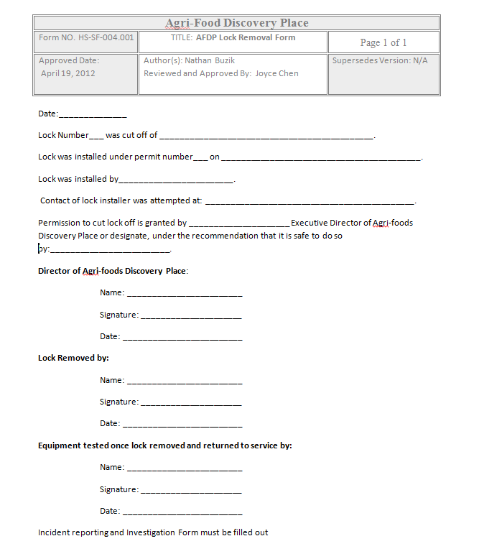
Reference
Alberta Occupational Health and Safety Code Part 15, Managing the Control of Hazardous Energy

DEFINITIONS
Any definitions listed in the following table apply to this document only with no implied or intended institution-wide use

Completent Worker | Adequately qualified, suitably trained and with sufficient experience to safely perform work without supervision or with only a minimal degree of supervision
Hot Work | Work in which a flame, is used or sparks or other sources of ignition may be produced.  - including cutting, welding, burning, air gouging, riveting, drilling, grinding and chipping  - using electrical equipment not classified for use in a hazardous locations and,  - introducing a combustion engine to a work process
Hazardous Energy | Electrical, mechanical, hydraulic, pneumatic, chemical, nuclear, thermal , gravitational, or any other form of energy that could cause injury due to the unintended motion, energizing, start-up or release of such stored or residual energy in machinery, equipment, piping, pipelines or process system.
Hazardous Location | A place where fire or exlosion hazards may exist due to flammable gases or vapours, flammable or combustible liquid, combustible dust, or ignitable fibres or flyings, as described in the Canadian Electrical Code
Isolated | To have sperated, disconnected, de-energized or depressurized

Approval:

________________________________ ____________________
Executive Director Date

________________________________ ____________________
Chair WHSC Date

